***Software Engineering******Lecture # 1***

***Course Objective***

* To familiarize students to the fundamental concepts, techniques, processes, methods and tools of Software Engineering,
* To help students to develop basic skills that will enable them to construct software of high quality – software that is reliable, and that is reasonably easy to understand, modify and maintain
* To foster an understanding of why these skills are important

***Lecture Objectives***

* To introduce software
* To introduce Software Engineering
* To describe Software Evolution
* To describe Software Paradigms
* To describe need of Software Engineering
* To describe the qualities of good Software

|  |  |  |
| --- | --- | --- |
|  | **Topics** | **Description** |
| **1** | **Introduction to the Course and Software Engineering** | Lay out of the course and overall introduction of the discipline of Software Engineering and what we will cover in the course. |
| **2** | **Software Processes & Software Process Models** | General introduction of processes and software engineer processes. Discussion of different process models and their practical implications. These process models include Waterfall model, evolutionary models and incremental models. |
| **3** | **Software Process Models (continued); Analysis modeling** | Software process models will be completed in the first lecture of this week. Analysis phase of software engineering will be introduced. |
| **4** | **Scenario based modeling** | Analysis modeling approaches (Object oriented analysis; Flow oriented analysis). Topic will include requirement gathering using use case diagrams, Activity diagrams, Swim lane diagrams. |
| **5** | **Flow oriented modeling** | **Data flow diagrams, Control flow diagrams, processing narratives** |
| **6** | **Behavioral modeling** | State diagrams, Sequence diagrams |
| **7** | **Class Diagrams** | How to create initial domain model and how to develop conceptual class diagram. Usefulness of domain model. |
| **8** | **Software Design** | General Introduction of Object-Oriented Design techniques and methods |
| **9** | **Software-Architecture** | Discussion of need of explicitly defining software architecture and its benefits. What are important determinant of selection of certain architecture or architecture style. Cost and benefit analysis of well know architectural style |
| **10** | **Source Code Management** | What are coding standards how essential they are? Discussion of software configuration management process |
| **11** | **Software Testing** | What is software testing process, what methods, tools and techniques are use to verify and validate the software. How software testing process is distributed over entire life cycle of software development. |
| **12** | **Software Maintenance** | What happen between software is deployed till the time it is retired. How software evolution occurs and how it is managed. |
| **13** | **Software Quality** | What is software quality, how can we ensure that software we develop is of acceptable quality. Software quality assurances imperatives. |
| **14** | **Software Business and Ethics** | Business of software is fast become a major GNP producer. Many rules and regulation are there to guide software industry. How business and regulation software engineering practices. (Special Reading) |

**Motivation**

* **Software can have huge impact in any aspect of our society**

**Where can we find software?**

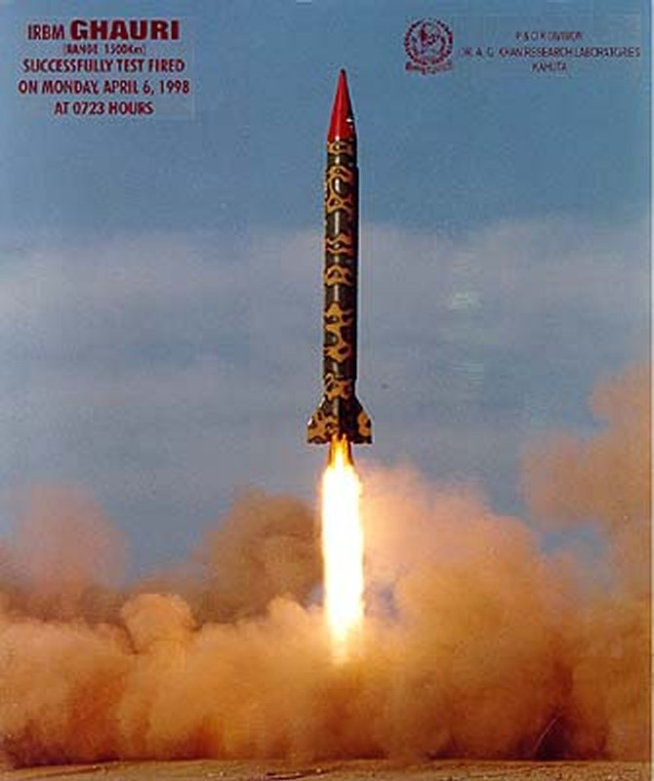

**Some popular ones…**

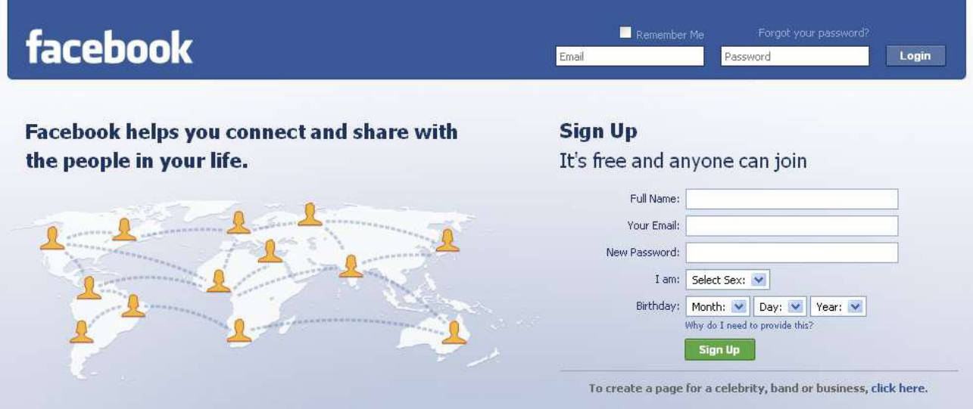





**Conclusion**

**Software is almost everywhere!!!**

* **Problems in software development**
* Common issues are
  + The final software does not fulfill the needs of the customer
  + Hard to extend and improve: if you want to add a functionality later its mission impossible
  + Bad documentation
  + Bad quality: frequent errors, hard to use, ...
  + More time and costs than expected

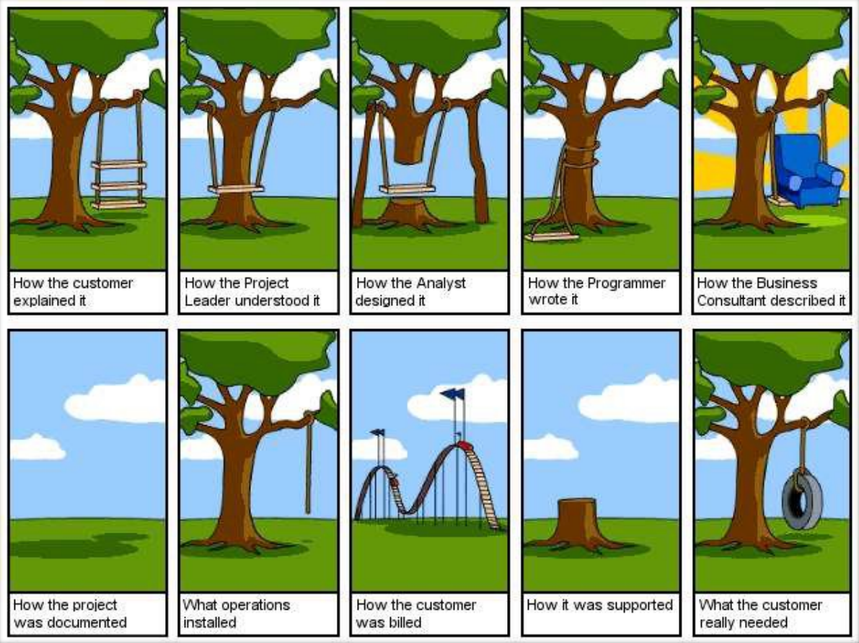

**But**

**that never happens?**

**right?**

**Wrong!**

* **Ariane 5 Flight 501**

**Cause: -** Design errors in the software

* <http://www.youtube.com/watch?v=kYUrqdUyEpI>
* **Conclusion**
* Programming is NOT enough!

*It is not enough to do your best: you must Know what to do, and THEN do your best.* -- W. Edwards Deming

* **And since…**

*A clever person solves a problem.*

*A wise person avoids it.*

*- Albert Einstein*

*Solution*

* **Software Engineering**

1. The application of a systematic, disciplined, quantifiable approach to the development, operation, and maintenance of software; that is the application of engineering to software.
2. The study of approaches as in (1)

-- IEEE Definition (1993)

**Software Engineering**

* **Objective is to produce software that is:**
* On time: is deliver at the established date.
* Reliable: does not crash.
* Complete: good documentation, fulfill customer needs.